**ABSTRACT**

TopAgro is basically project of Agriculture Marketing for encouraging farmers by improving their income and maintaining stability of farm produce in market .In the absence of sound marketing facilities, the farmers have to depend upon local traders and middlemen for the disposal of their farm produce which is sold at throw away price. So, TopAgro provides service for farmers to sell their produce to whomever they like at their expected price.

At TopAgro we are creating a centralized platform for farmers, vendors, middlemen, bulk buyers to buy and sell the farm produce at justified rate. Leading to bring transparency, better price discovery & timely agriculture market.

**Contents**

|  |  |
| --- | --- |
| 1.Introduction  1.1 Existing techniques  1.2 Proposed system  1.3 Features of proposed system | 3 |
| 2. Software Requirement Specification  2.1 Introduction  2.1.1 Purpose  2.1.2 Scope  2.1.3 Developer’s Responsibilities overview  2.2 Overall Description  2.2.1 Product functions  2.2.2 User Characteristics  2.2.3 Assumptions and Dependencies | 4 |
| 3.System Design  3.1 Activity Diagram  3.2 Sequence Diagram  3.3 Use Case Diagram | 5 |
| 4. Technical Specifications  4.1 Used programming languages  4.2 Used Database | 8 |
| 5.Software Implementation  5.1 Problem statement  5.2 System architecture | 11 |
| 6. Result Snapshot | 12 |
| 7. Conclusion and future work  8.1 Conclusion   * 1. Future work | 20 |
| 8. References | 21 |

**1 .Introduction**

* 1. **Existing Techniques**

Today in market we have systems and committees Like National Horticulture Board (NHB), Agricultural Produce Market Committee (APMC), National Agricultural Cooperative Marketing Federation of India Ltd (NAFED)

**1.2 Proposed System**

Simple user friendly GUI where farmers can be members of our portal. They can log in fill in the details like their location .production type, amount of production, expected price. For quality assurance our inspection team will be inspecting quality, availability, weight of produce which was registered on our portal. Then the produce will be transported to our nearby warehouses for storing, preserving, cleaning, grading, and packaging. Online Auction will be carried out amongst vendors, middlemen, bulk buyers & local traders for that produce. Whoever offering more money, we will be delivering produce to appropriate buyer ensuring timely delivery and settlement of payment.

**1.3 Features of Proposed System:**

1. Empowering farmers by improving their income

2. Online Auction for vendors across district/state.

3. Transferring the produce where there is the shortage of food.

4. Website reduces the efforts of farmers by selling online and not visiting Mandies (food market) where he is offered less money.

5. We are for providing platform for Vendors to buy produce which is not available in their region.

6. The Website maintains all the record of transaction farm produce, farmers, and vendors.

7. Farmers and vendors can have online transaction with us.(optional).

### 2. Software Requirement Specification

#### Introduction

* + 1. **Purpose**

The purpose of this system is to interact with Farmers and help them in improving there income by providing platform to sale their produce on their expected price.

**2.1.2 Scope**

The website will be designed for use as long as the hardware and operating systems

Specified in this document remain available.

**2.1.3 Developer’s Responsibilities overview**

The developer is responsible for-

1. Developing the system.
2. Keeping Updates time to time
3. Administrative panel will be handled.
4. Accepting and Rejecting the pending requests of farmers to sale their produce and request of vendors to purchase the available produce.
   1. **Overall Description**

**2.2.1 Product Functions**

Functionalities required:

1. When website will be hosted, it will be available to all.
2. Internet connection needed for accessing website

**2.2.2 User Characteristics**

The user is required to know basic knowledge of accessing website.

* + 1. **Assumptions and Dependencies**

1. The user must have knowledge about current market situations and prices
2. User must have internet connection for accessing website and session of each user will be maintained.

**3. System Design**

**3.1 Activity Diagram**

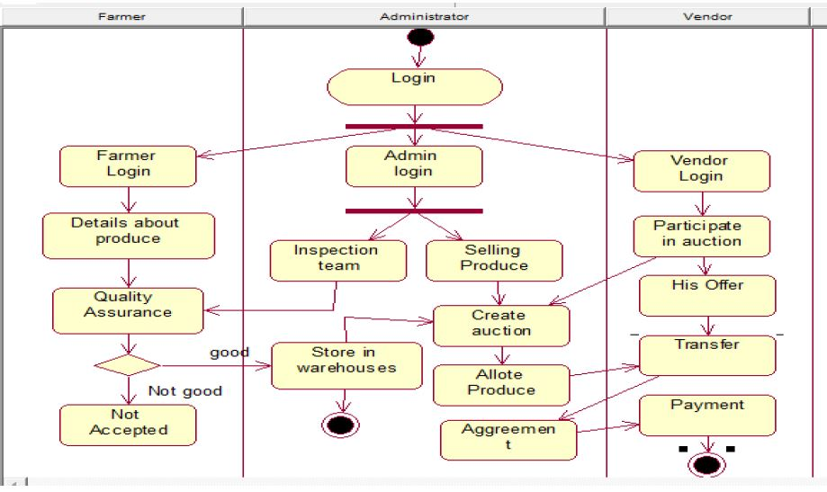

*Figure 5.1: Activity diagram*

**3.2 Sequence Diagram**

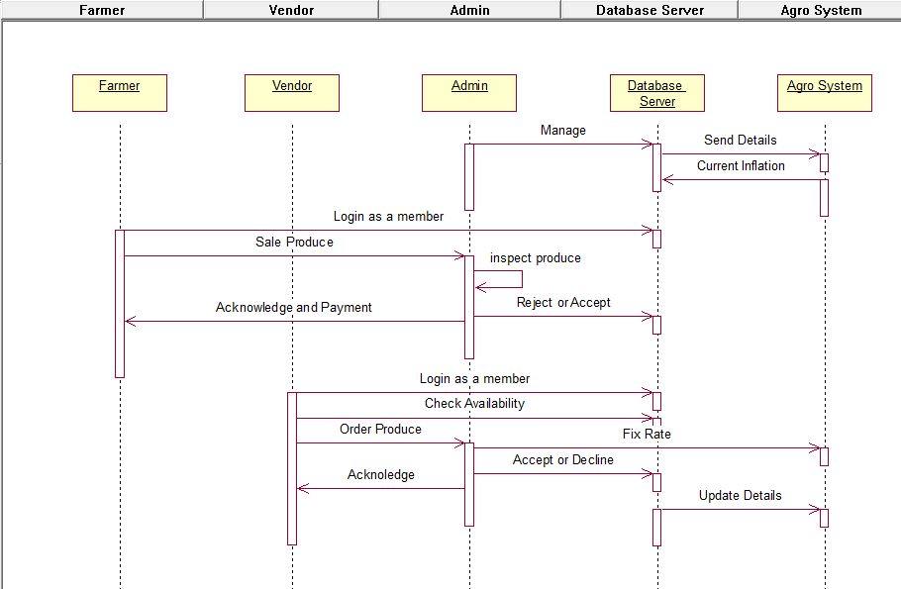

*Figure 5.2: Sequence diagram*

**3.3 Use case Diagram**

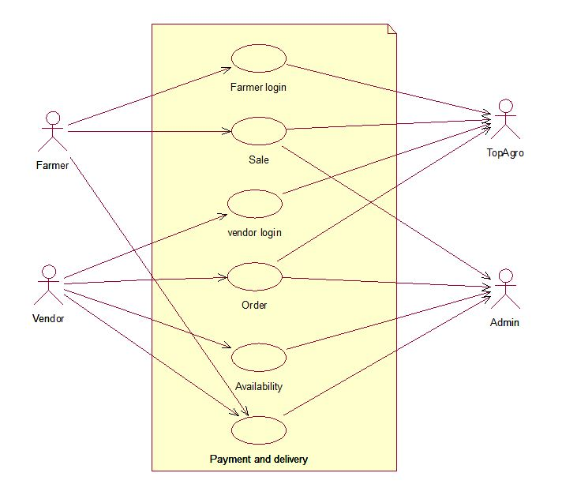

*Figure 5.3: use case diagram*

### 4. Technical Specification

### 4.1 Used programming languages

### HTML-

HTML is a markup language for describing web documents (web pages). HTML stands for **Hyper Text Markup Language.** A markup language is a set of markup HTML documents are described by HTML tag. Each HTML tag describes different document content

HTML tags are **keywords** (tag names) surrounded by **angle brackets**:

<tagname>content</tagname>

* HTML tags normally come **in pairs** like <p> and </p>
* The first tag in a pair is the **start tag,** the second tag is the **end tag**
* The end tag is written like the start tag, but with a **slash** before the tag name

Web Browser: The purpose of a web browser (Chrome, IE, Firefox, Safari) is to read HTML documents and display them.

**CSS-**

* **CSS** stands for **C**ascading **S**tyle **S**heets
* CSS describes **how HTML elements are to be displayed on screen, paper, or in other media**
* CSS **saves a lot of work**. It can control the layout of multiple Web pages all at once
* External Style Sheets are stored in **CSS files**

CSS is used to define styles for your web pages, including the design, layout and variations in display for different devices and screen sizes.

**BOOTSTRAP –**

* Bootstrap is a free front-end framework for faster and easier web development
* Bootstrap includes HTML and CSS based design templates for typography, forms, buttons, tables, navigation, modals, image carousels and many other, as well as optional JavaScript plugins
* Bootstrap also gives you the ability to easily create responsive designs

Advantages of Bootstrap:

* **Easy to use:** Anybody with just basic knowledge of HTML and CSS can start using Bootstrap
* **Responsive features:** Bootstrap's responsive CSS adjusts to phones, tablets, and desktops
* **Mobile-first approach:** In Bootstrap 3, mobile-first styles are part of the core framework
* **Browser compatibility:** Bootstrap is compatible with all modern browsers (Chrome, Firefox, Internet Explorer, Safari, and Opera)

**JAVA SCRIPT –**

JavaScript is the most popular programming language in the world.

JavaScript can do.:

## JavaScript Can Change HTML Content

## JavaScript Can Change HTML Attribute.

## JavaScript Can Change HTML Styles (CSS)

* JavaScript Can Validate Data

**PHP –**

PHP is an acronym for "PHP: Hypertext Preprocessor"PHP is a widely-used, open source scripting language. PHP scripts are executed on the server. PHP is free to download and use.PHP files can contain text, HTML, CSS, JavaScript, and PHP code. PHP code are executed on the server, and the result is returned to the browser as plain HTML. PHP files have extension ".php".

PHP can generate dynamic page content.. PHP can create, open, read, write, delete, and close files on the server. PHP can collect form data. PHP can send and receive cookies. PHP can add, delete, modify data in your database. PHP can be used to control user-access. PHP can encrypt data.

**4.2 Used Database:**

**MYSQL-**

* MySQL is a database system used on the web
* MySQL is a database system that runs on a server
* MySQL is ideal for both small and large applications
* MySQL is very fast, reliable, and easy to use
* MySQL uses standard SQL
* MySQL compiles on a number of platforms
* MySQL is free to download and use
* MySQL is developed, distributed, and supported by Oracle Corporation
* MySQL is named after co-founder Monty Widenius's daughter: My

The data in a MySQL database are stored in tables. A table is a collection of related data, and it consists of columns and rows.

Databases are useful for storing information categorically. A company may have a database with the following tables.

* Sale
* Farmer
* Vendors
* Available produce
* Orders

PHP combined with MySQL are cross-platform.

**5. Software Implementation**

#### 5.1 Problem Statement

Developing Website Portal for Farmers and Vendors, Where Farmers can sale their Produce with their expected prices and current market rates, and Vendors can check availability of each Produce, and they can place order to purchase the produce on given market price.

#### 5.2 System Architecture

The Website having three different Modules i.e. Farmer, Vendor and Admin. Website start with Home.html page. This page having the details about Aim, Products and services, developers contact details information. Then after clicking to Let’s Proceed, it will show the index.html page, in which farmer, vendor can Sign Up, Sign In.

After farmer login, afterlogin1.php page will be displayed. In this page farmer can sale their Produce by putting their expected price with quality and quantity. He can check his own history for his sale, which is accepted, pending and rejected by admin. He can also check availability of Produces and place the orders.

After vendor login, afterlogin2.php page will be displayed. In this page vendor can check availability of Produces and place the orders according to is required quality and quantity, Price of produce will be calculated automatically and will be displayed to him according to his order. Vendors Order history will also be visible to him. So which are accepted, rejected and pending, he can check it.

Then main role is of Admin, he maintains all the requests of sale and purchase by farmers and vendors respectively. And gives response by accepting or rejecting the Pending requests of produces.

As per the aim, Transparency between farmers and vendors is maintained by aware them with each other’s.

**6. Result Snapshot**

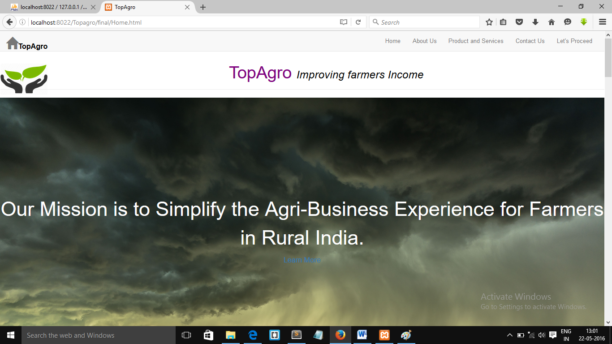

**Fig.6.1 Home.html**

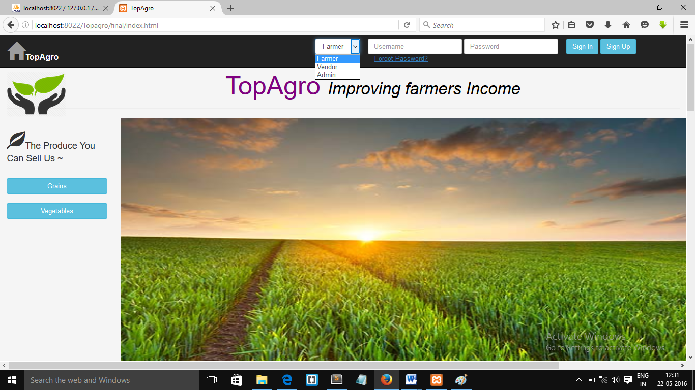

**Fig.6.2 index.html**

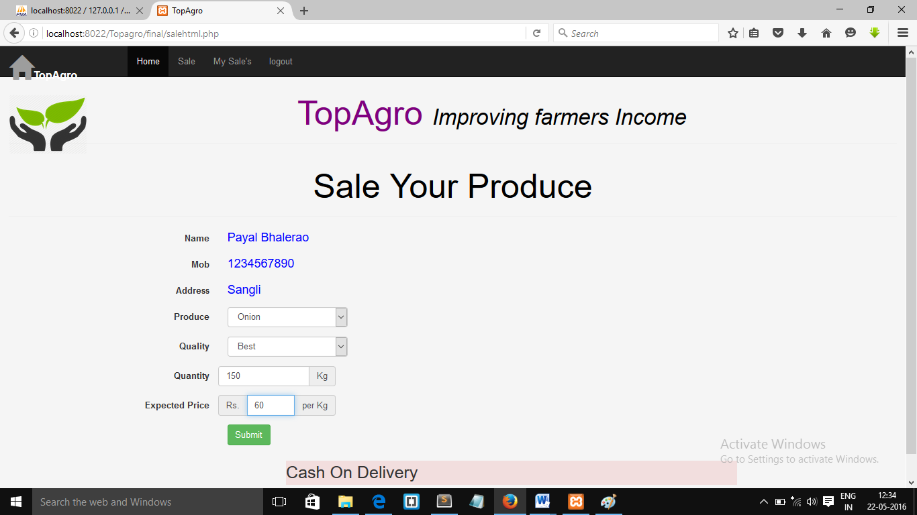

**Fig.6.3 Farmers Produce sale Form**

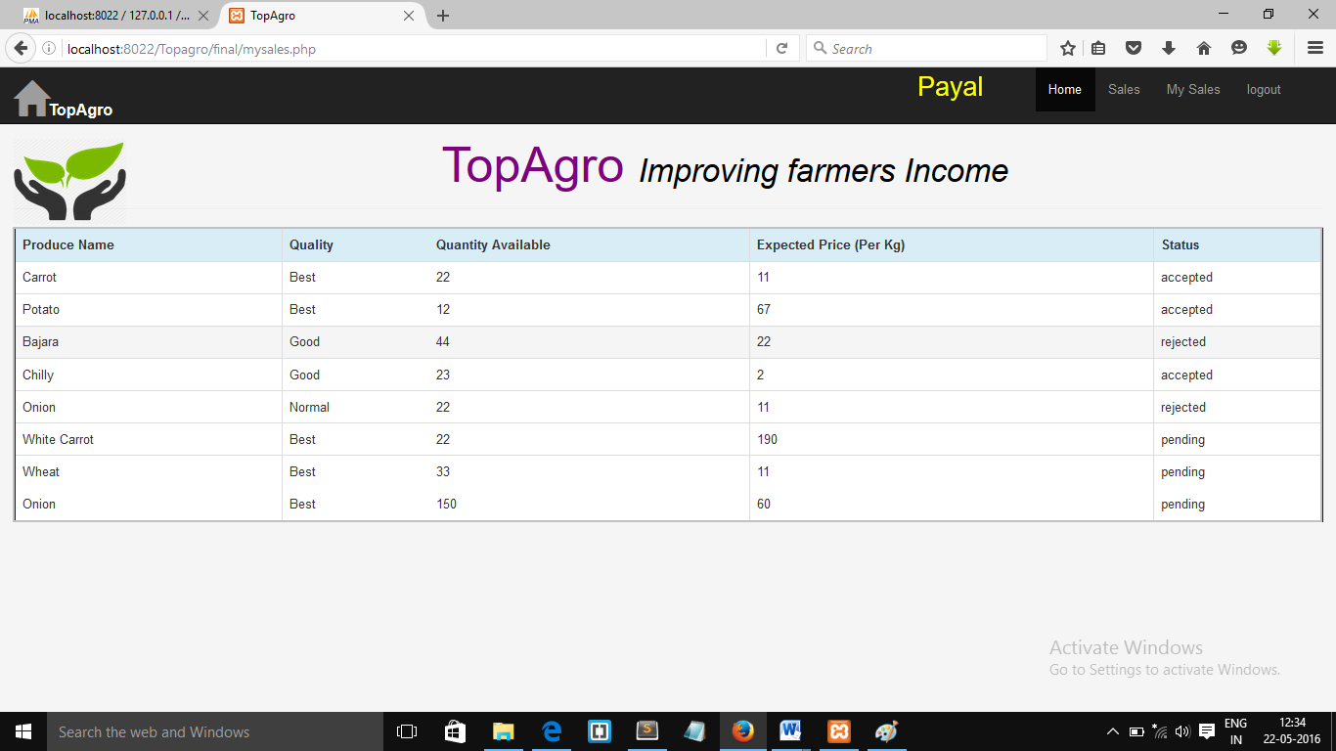

**Fig. 6.4 Farmers Sale History**

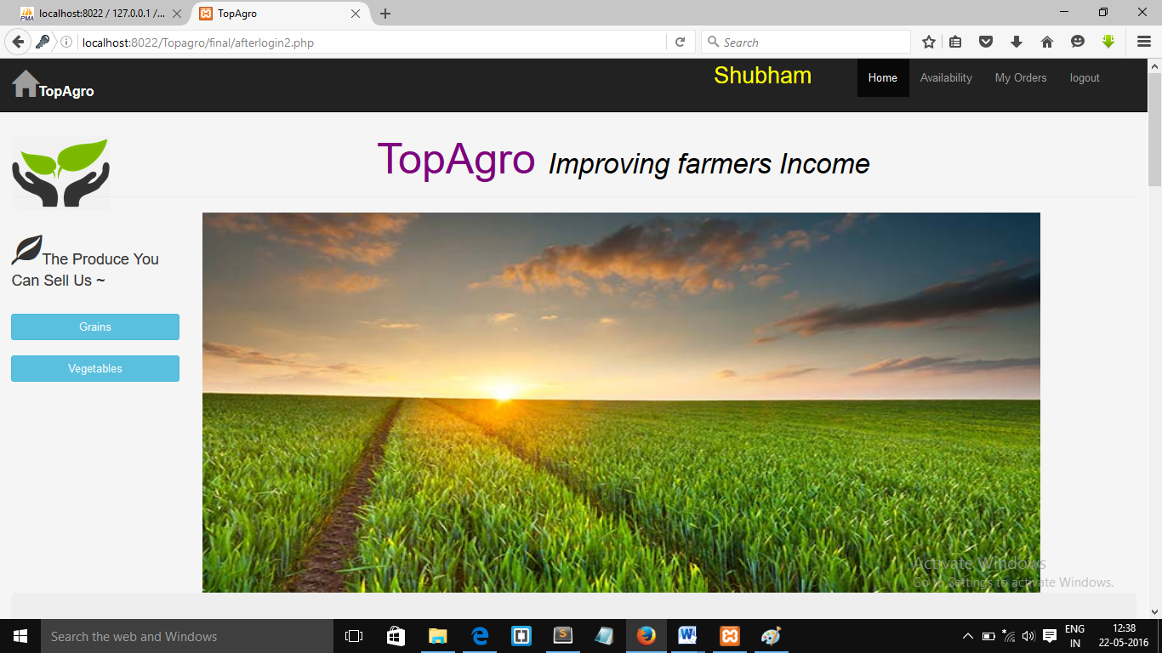

**Fig. 6.5 Vendor Logged In page**

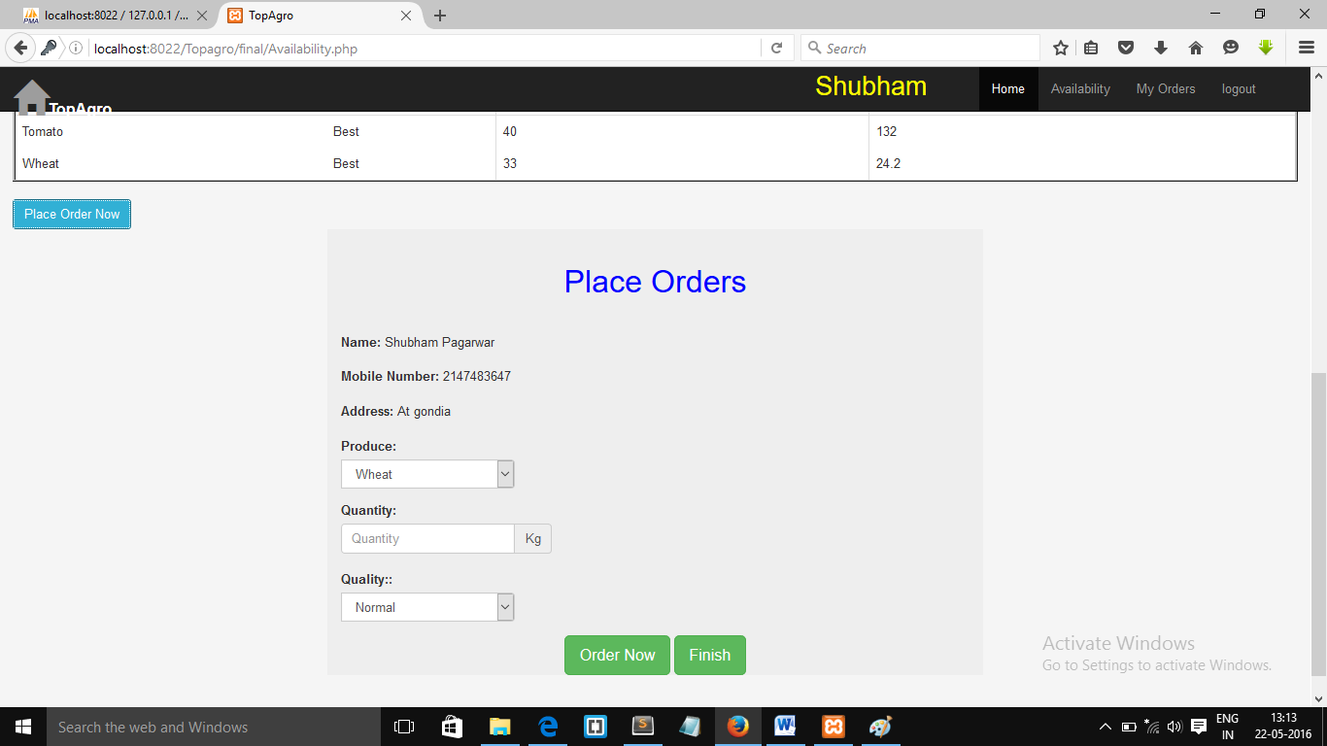

**Fig. 6.6 Vendor Purchase form**

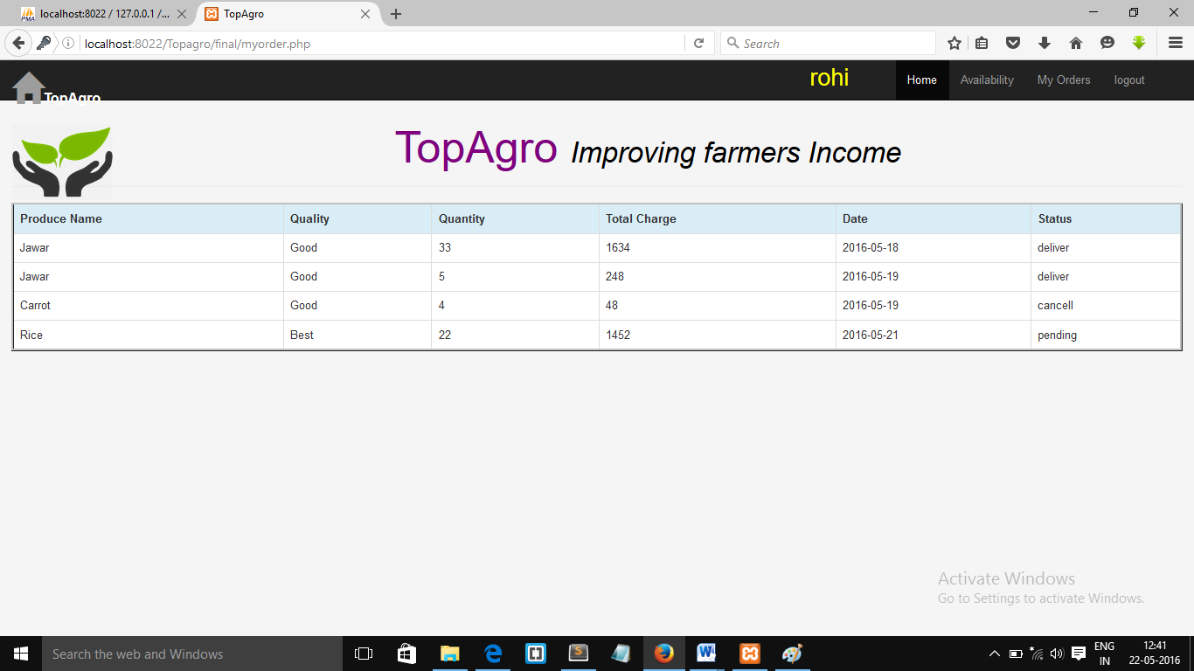

**Fig. 6.7. Vendors Orders History**

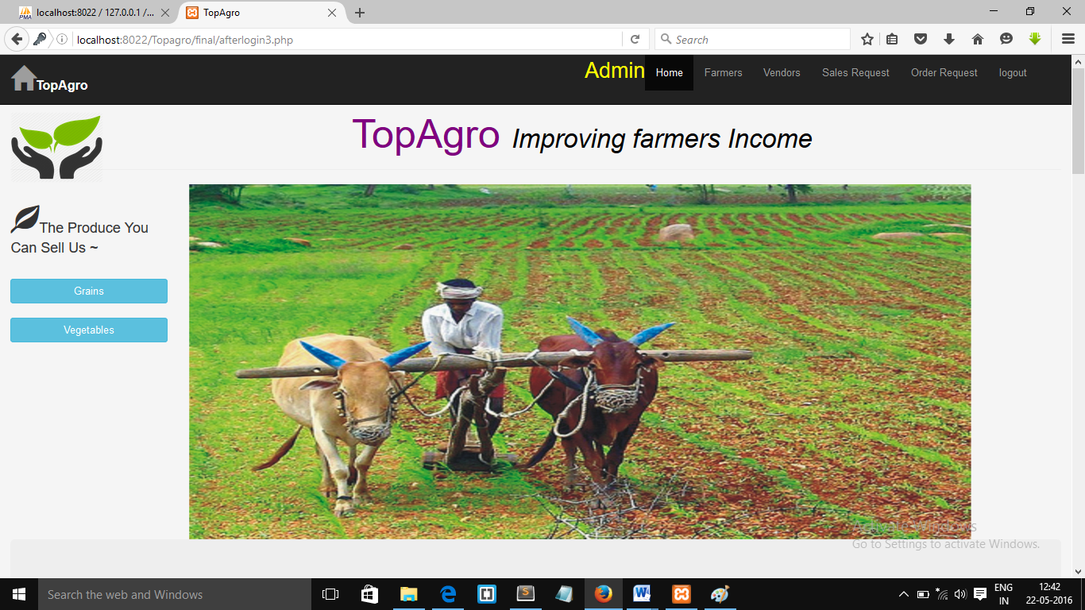

**Fig. 6.8 Admin Logged In**

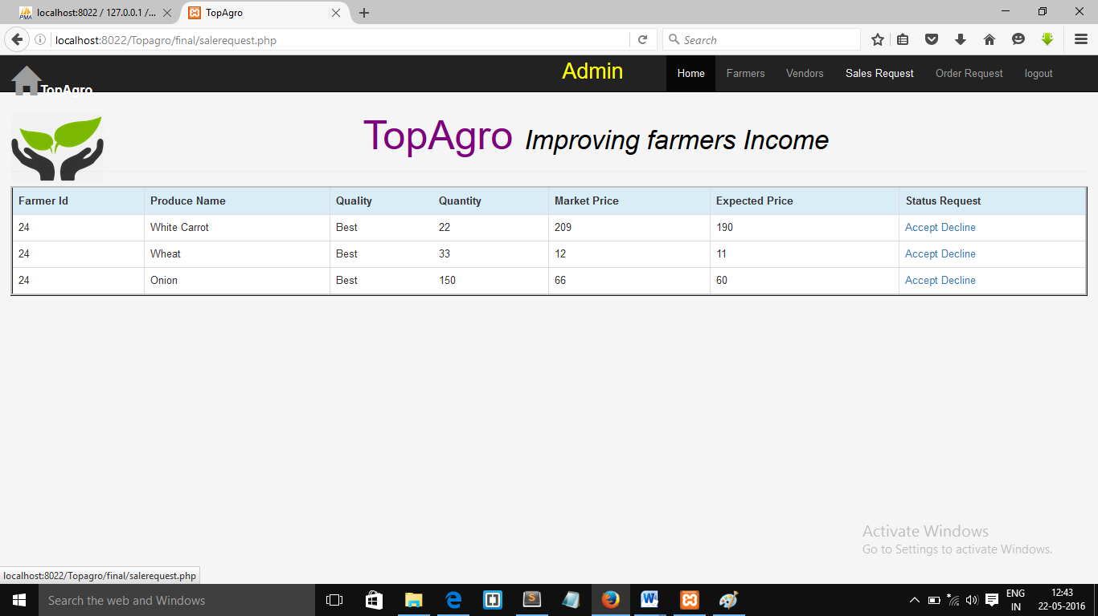

**Fig. 6.9 Admin Response to Request**

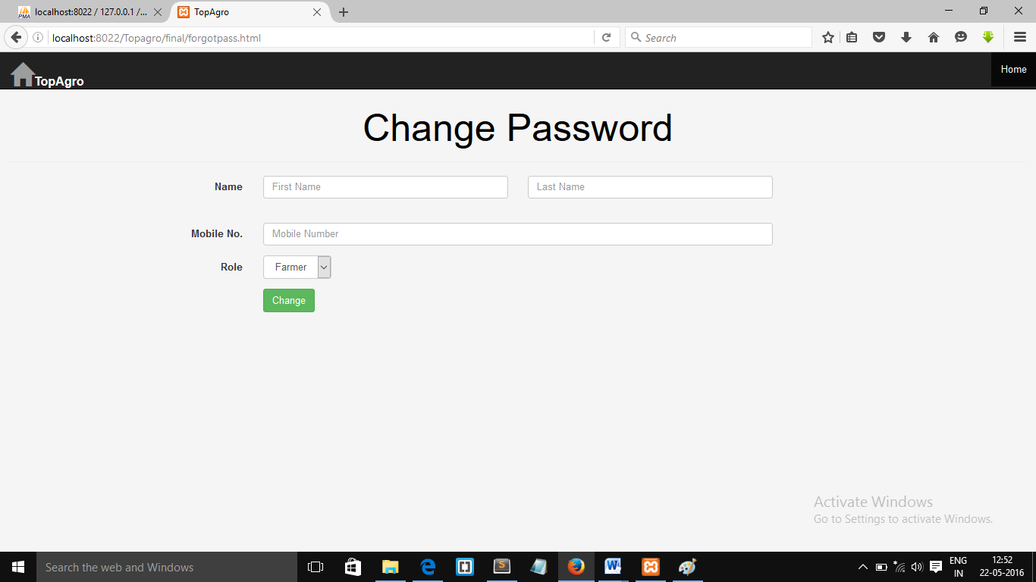

**Fig. 6.9 Change Password**

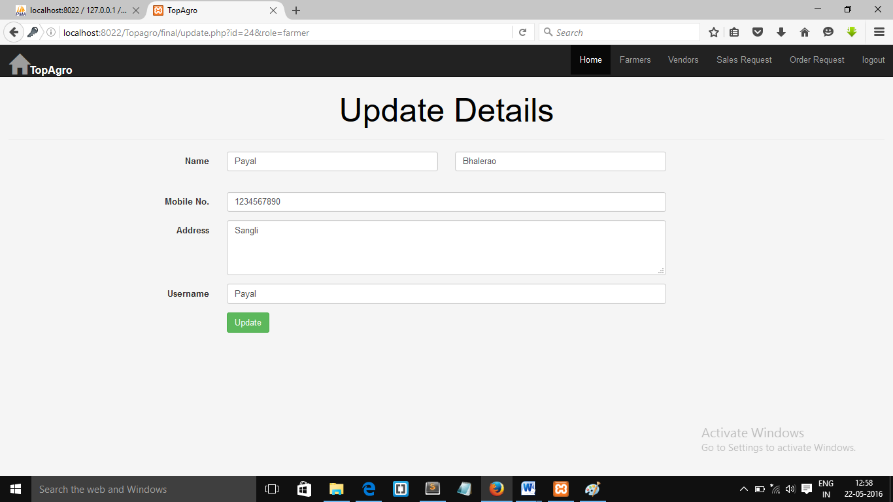

**Fig. 6.9 Admin Able to update details of vendors or farmer**

### 7. Conclusion and Future Work

**7.1 Conclusion**

We are trying to change the current situation of agriculture marketing by reaching to the farmer level and help them improve their income. As well as agriculture marketing will become the part of a current popular trade ‘Digital India’.

. **7.2 Future Work**

1. Creating an online transportation system like Paytm.
2. Adding the services for providing fertilizers.
3. Target as an group of customers
4. Moving towards the agricultural flipcart.

**8. References**

* www.W3C.com
* www.tutorialspoint.com
* Bootstrap.org
* Agrostar.com